Day 6
1.Binary search tree
#include <stdio.h>
#include <stdlib.h>

struct Node {
int data;
struct Node *left, *right;
};

struct Node* insert(struct Node* root, int x) {
if (root == NULL) {
root = (struct Node*)malloc(sizeof(struct Node));
root->data = x;
root->left = root->right = NULL;
return root;
}
if (x < root->data)
root->left = insert(root->left, x);
else
root->right = insert(root->right, x);
return root;
}

int search(struct Node* root, int key) {
if (root == NULL) return 0;
if (root->data == key) return 1;
if (key < root->data)
return search(root->left, key);
else
return search(root->right, key);
}

void inorder(struct Node* root) {
if (root != NULL) {
inorder(root->left);
printf("%d ", root->data);
inorder(root->right);
}
}

int main() {
struct Node* root = NULL;

root = insert(root, 10);
insert(root, 5);
insert(root, 20);
insert(root, 3);
insert(root, 7);

printf("Inorder: ");
inorder(root);

if (search(root, 7))
printf("\n7 found");
else
printf("\n7 not found");

return 0;
}
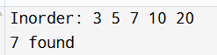
2.BST handle 0,1,2 children cases
#include <stdio.h>
#include <stdlib.h>

struct Node {
int data;
struct Node *left, *right;
};

struct Node* newNode(int x) {
struct Node* n = (struct Node*)malloc(sizeof(struct Node));
n->data = x;
n->left = n->right = NULL;
return n;
}

struct Node* insert(struct Node* root, int x) {
if (root == NULL) return newNode(x);
if (x < root->data)
root->left = insert(root->left, x);
else
root->right = insert(root->right, x);
return root;
}

struct Node* minValue(struct Node* root) {
while (root->left != NULL)
root = root->left;
return root;
}

struct Node* deleteNode(struct Node* root, int key) {
if (root == NULL) return NULL;

if (key < root->data)
root->left = deleteNode(root->left, key);
else if (key > root->data)
root->right = deleteNode(root->right, key);
else {
if (root->left == NULL) {
struct Node* t = root->right;
free(root);
return t;
}
if (root->right == NULL) {
struct Node* t = root->left;
free(root);
return t;
}
struct Node* t = minValue(root->right);
root->data = t->data;
root->right = deleteNode(root->right, t->data);
}
return root;
}

void inorder(struct Node* root) {
if (root) {
inorder(root->left);
printf("%d ", root->data);
inorder(root->right);
}
}

int main() {
struct Node* root = NULL;

root = insert(root, 40);
insert(root, 20);
insert(root, 60);
insert(root, 10);
insert(root, 30);

inorder(root);
root = deleteNode(root, 20);
printf("\nAfter delete:\n");
inorder(root);

return 0;
}
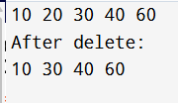
3.playlist
#include <stdio.h>
#include <stdlib.h>
#include <string.h>

struct Node {
char song[20];
struct Node *next;
};

struct Node *last = NULL;

void addSong(char *name) {
struct Node *n = malloc(sizeof(struct Node));
strcpy(n->song, name);

if (last == NULL) {
last = n;
n->next = n;
} else {
n->next = last->next;
last->next = n;
last = n;
}
}

void removeSong(char *name) {
struct Node *curr = last->next, *prev = last;

do {
if (strcmp(curr->song, name) == 0) {
prev->next = curr->next;
if (curr == last) last = prev;
free(curr);
return;
}
prev = curr;
curr = curr->next;
} while (curr != last->next);
}

void play(int k) {
struct Node *temp = last->next;
for (int i = 0; i < k; i++) {
printf("Playing %s\n", temp->song);
temp = temp->next;
}
}

int main() {
addSong("A");
addSong("B");
addSong("C");
play(7);
removeSong("C");
play(5);

return 0;
}
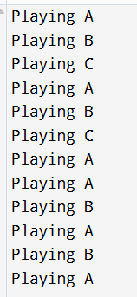
4.circular linked list
#include <stdio.h>
#include <stdlib.h>

struct Node {
int seats;
struct Node *prev, *next;
};

struct Node *head = NULL;

void addFront(int s) {
struct Node *n = malloc(sizeof(struct Node));
n->seats = s;
n->prev = NULL;
n->next = head;
if (head) head->prev = n;
head = n;
}

void addBack(int s) {
struct Node *n = malloc(sizeof(struct Node));
n->seats = s;
n->next = NULL;
if (!head) { n->prev = NULL; head = n; return; }
struct Node *t = head;
while (t->next) t = t->next;
t->next = n; n->prev = t;
}

void removePos(int p) {
struct Node *t = head;
for (int i = 1; t && i < p; i++) t = t->next;
if (!t) return;
if (t->prev) t->prev->next = t->next;
else head = t->next;
if (t->next) t->next->prev = t->prev;
free(t);
}

void display() {
struct Node *t = head, *last;
while (t) { printf("%d ", t->seats); last = t; t = t->next; }
printf("\n");
while (last) { printf("%d ", last->seats); last = last->prev; }
printf("\n");
}

int main() {
addFront(40);
addBack(50);
addBack(60);
addBack(70);

display();
removePos(2);
display();
return 0;
}
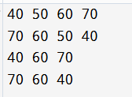
5.height of bst.balance or not

#include <stdio.h>
#include <stdlib.h>

struct Node {
int data;
struct Node *left, *right;
};

struct Node* newNode(int x) {
struct Node* n = malloc(sizeof(struct Node));
n->data = x;
n->left = n->right = NULL;
return n;
}

int height(struct Node *root) {
if (root == NULL) return 0;
int l = height(root->left);
int r = height(root->right);
return (l > r ? l : r) + 1;
}

int isBalanced(struct Node *root) {
if (root == NULL) return 1;

int lh = height(root->left);
int rh = height(root->right);

if (abs(lh - rh) <= 1 &&
isBalanced(root->left) &&
isBalanced(root->right))
return 1;

return 0;
}

int main() {
struct Node *root = newNode(10);
root->left = newNode(5);
root->right = newNode(20);
root->left->left = newNode(3);

printf("Height: %d\n", height(root));

if (isBalanced(root))
printf("Tree is Balanced\n");
else
printf("Tree is Not Balanced\n");

return 0;
}
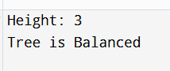
6.Arithmetic operations
#include <stdio.h>
#include <stdlib.h>

int main() {
int n;
int *arr;
int sum = 0, product = 1;

printf("Enter number of elements: ");
scanf("%d", &n);

arr = (int*)malloc(n * sizeof(int));

if (arr == NULL) {
printf("Memory allocation failed");
return 1;
}

printf("Enter %d numbers:\n", n);
for (int i = 0; i < n; i++) {
scanf("%d", &arr[i]);
sum += arr[i];
product *= arr[i];
}

printf("Sum = %d\n", sum);
printf("Difference = %d\n", arr[0]);
for (int i = 1; i < n; i++)
printf(" - %d", arr[i]);

printf("\nProduct = %d\n", product);
printf("Average = %.2f\n", (float)sum / n);

free(arr);
return 0;
}
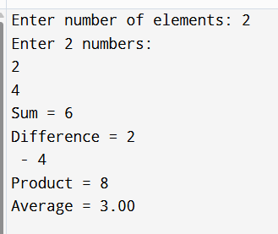

7.length of string
#include <stdio.h>

int main(int argc, char *argv[]) {
if (argc < 2) {
printf("Please provide a string as argument\n");
return 1;
}
char *s = argv[1];
int len = 0;
while (s[len] != '\0')
len++;

printf("%d\n", len);
return 0;
}
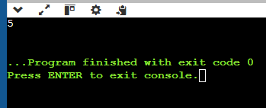
8.validate ranges
#include <stdio.h>
#include <stdlib.h>

#define MIN -1000
#define MAX 1000

int validateRange(int n) {
if (n < MIN || n > MAX)
return 0;
return 1;
}

void findQuadrant(int x, int y) {
if (x == 0 && y == 0)
printf("Point lies at the Origin.\n");
else if (x == 0)
printf("Point lies on Y-axis.\n");
else if (y == 0)
printf("Point lies on X-axis.\n");
else if (x > 0 && y > 0)
printf("Quadrant: I\n");
else if (x < 0 && y > 0)
printf("Quadrant: II\n");
else if (x < 0 && y < 0)
printf("Quadrant: III\n");
else
printf("Quadrant: IV\n");
}

int main() {
int x, y;

printf("Enter x coordinate: ");
if (scanf("%d", &x) != 1) {
printf("Error: Invalid input type for x.\n");
return EXIT_FAILURE;
}

printf("Enter y coordinate: ");
if (scanf("%d", &y) != 1) {
printf("Error: Invalid input type for y.\n");
return EXIT_FAILURE;
}

if (!validateRange(x) || !validateRange(y)) {
printf("Error: Input out of range.\n");
printf("Valid range is [%d to %d].\n", MIN, MAX);
return EXIT_FAILURE;
}

printf("\nOriginal Input: x = %d, y = %d\n", x, y);

int rx = y;
int ry = x;

printf("Reversed Input: x = %d, y = %d\n", rx, ry);

findQuadrant(rx, ry);

printf("Status: Operation completed successfully.\n");
return EXIT_SUCCESS;
}

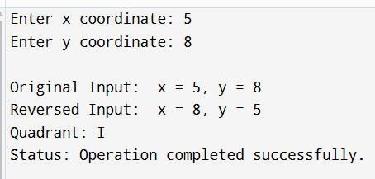
9.Macros
#include <stdio.h>

#define LOG(tag, fmt, ...) \
printf("[%s] %s:%d %s(): " fmt "\n", \
tag, __FILE__, __LINE__, __func__, ##__VA_ARGS__)

#define LOCK_INFO(...) LOG("INFO", __VA_ARGS__)
#define LOCK_ERR(...) LOG("ERROR", __VA_ARGS__)
#define LOCK_GIVEUP(...) LOG("GIVEUP", __VA_ARGS__)
#define POST(...) LOG("POST", __VA_ARGS__)

void acquire_lock(int r)
{
LOCK_INFO("Trying lock, retries=%d", r);

if (r > 3) {
LOCK_GIVEUP("Retry limit exceeded");
return;
}

POST("Lock acquired");
}

int main(void)
{
acquire_lock(5);
return 0;
}
10.trigger and capture segmentation fault and analyse with GDP practise and fix root cause

#include <stdio.h>

void crash() {
int *p = NULL;
*p = 10;
}

int main() {
crash();
return 0;
}

Fixing:
#include <stdlib.h>
#include <stdio.h>

void crash_fixed() {
int *p = malloc(sizeof(int));

if (p == NULL) {
return;
}

*p = 10;
free(p);

}

int main() {
crash_fixed();
printf("segmentation fault removed");
return 0;
}
